Snapchat Fake Page with Flask

We are going to start project by using PyCharm editor. The first step is creating a new project having the same name of our project “Snapchat”. In this project we will use Anaconda as an interpreter to create a virtual environment. The name of the environment will be the same name of the project. The python version in this project is 3.7.

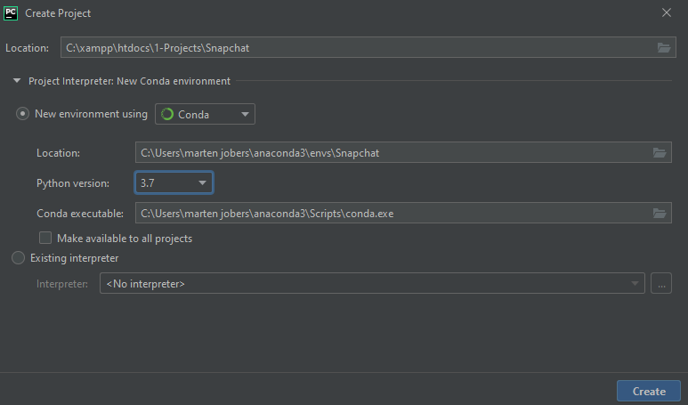

After we’ve created this project, we can check in many ways that our virtual environment has been created, the simplest way by using the Anaconda Navigator. We can search if our environment exist or not by going to “Environments” field and type the environment name on the search bar.

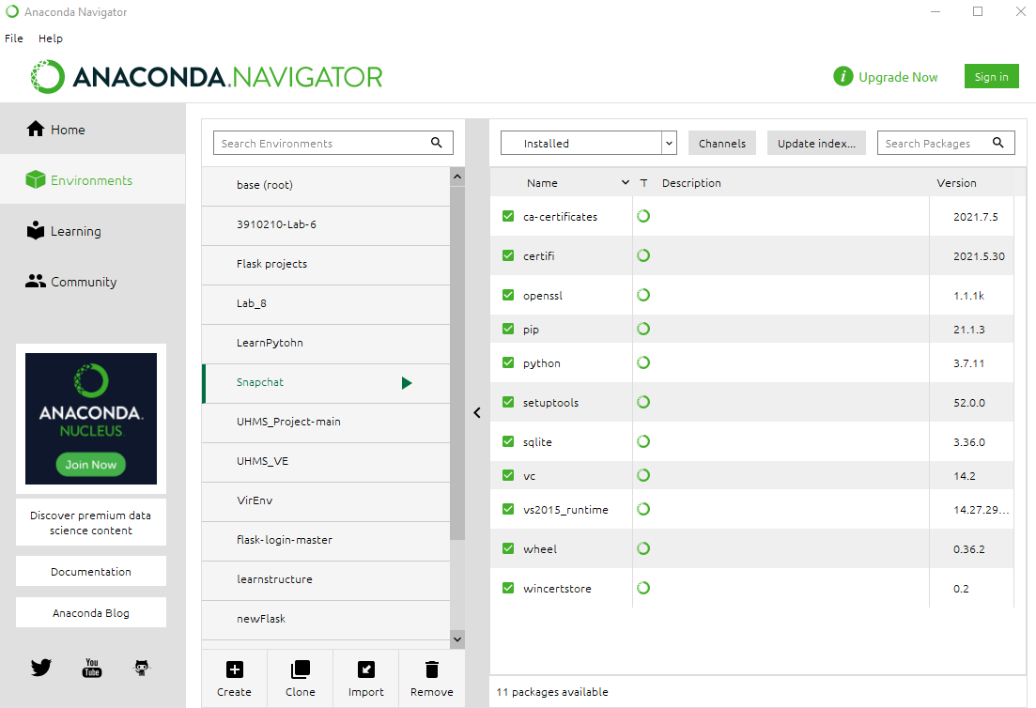

The other way by using the anaconda command prompt, but here we can only list all the environment names that are exist by using this command line

conda env list

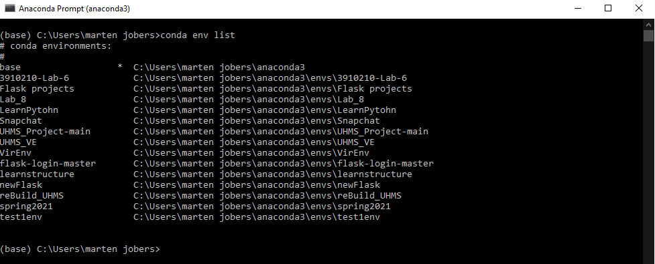

Basic project structure: the project structure has to main folders a templates folder where we keep out html files, a static folder where all CSS, JS, etc. are kept, and an app python file to run the project.

Note: The Documentation folder is only for documenting this project.

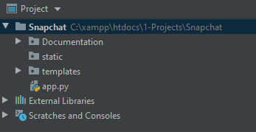

Now we want to create a requirements.txt file to manage our project requirements so we can track unsatisfied requirements and create a virtual environment based on the requirements.txt file.

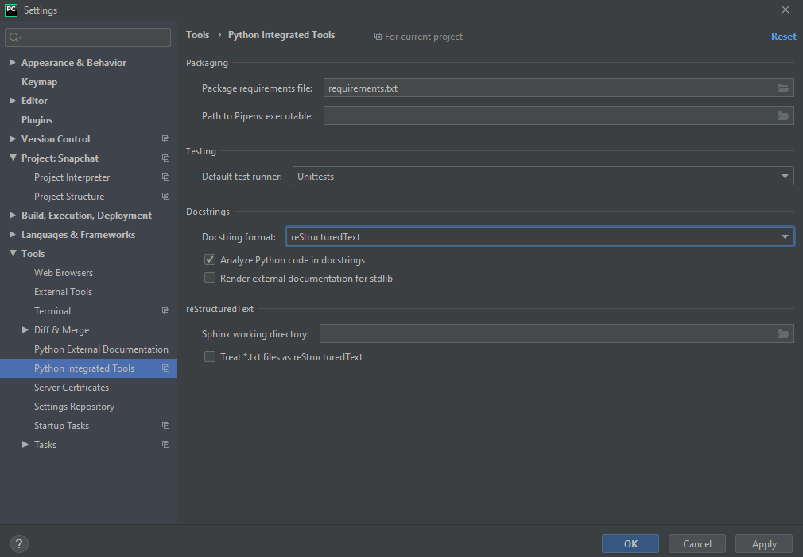

There are too many ways to generate a requirements.txt file, as the snapshot above, I’ve created the requirements.txt file by using the python integral tools. Another way to create it by using this command line.



-Now we need to install flask by using this command line:



* Let us move to create the app.py file

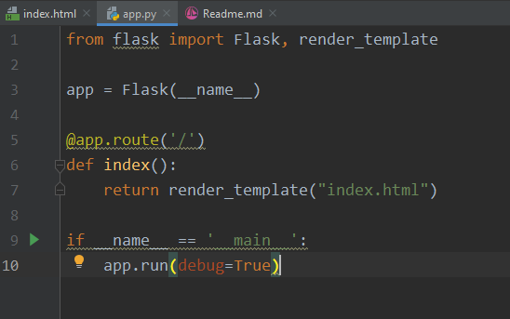

we imported the flask library to initialize the app variable and render template to render the index.html file that we are going to create later on.